WEDE5020POE
Website Project Proposals
Two proposed website solutions for local South African organisations

Module
Web Development (Introduction) — WEDE5020
Student
Kamogelo Mabiletsa
Student No: ST10479701
2026

Proposal 1: Thuba Rush Kota Joint Website

1. Organisation Overview
Business Name: Thuba Rush Kota Joint
Background: An independent South African street food outlet specializing in kotas. Located at Live Easy, Opera Plaza, 230 Pretorius Street, Pretoria Central. Known as the "Home of Private School Kota", it has grown a strong customer base through word-of-mouth and Instagram with 3.1K+ followers.
Mission: To provide large, quality kotas that unite the Pretoria CBD community through affordable, filling meals.
Vision: To become the most well-known kota brand in Pretoria and expand to multiple locations.
Target Market: Students, young professionals, office workers in Pretoria CBD looking for affordable meals, plus food lovers who follow social media trends.

2. Website Goals and Objectives
- Boost online presence beyond Instagram and Google Business.
- Allow customers to order via WhatsApp/online and display the complete menu with prices.
KPIs: Achieve 50+ WhatsApp/online orders monthly within 6 months, 500+ site visits per month, and higher traffic from Instagram to the website.

3. Current Online Presence Analysis
Current state: No standalone website. Only a Google Business profile and Instagram page.
Strengths: Loyal social following and good reviews.
Weaknesses: No central site for orders, pricing, or direct contact. Too dependent on third-party platforms.
Needed improvement: Build a dedicated website to combine menu, ordering, and location info.

4. Proposed Features & Functionality
Page/Feature | What it will do
Homepage | Introduce the brand, show food photos, and have a clear button to view menu or order
About Us | Short brand story, explain "Home of Private School Kota", show location
Menu | Full kota menu with prices, sizes, extras. Editable through CMS
WhatsApp Ordering | Fixed WhatsApp button linking to 066 529 2918 for quick orders
Location & Contact | Google Maps embed, address, trading hours, phone number
Gallery | Carousel of food photos from Instagram
Reviews | Show Google rating and customer testimonials

5. Design & User Experience
Colors: Bold red, orange, black for energy and appetite appeal, with gold accents matching packaging.
Fonts: Bold sans-serif for headings, clean readable font for body text.
Layout: Mobile-first, single-page scroll. Target audience uses phones. Includes sticky WhatsApp order button and quality food images.
UX: Easy navigation, strong call-to-action buttons, fast loading for on-the-go users.

6. Technical Requirements
Domain: http://thubarush.co.za
Hosting: Shared hosting via a SA provider like Afrihost/Domains.co.za
Tech Stack: HTML, CSS, JavaScript on a lightweight CMS like WordPress for easy menu updates.

7. Timeline & Milestones

Part 1: Proposal approval → Part 2: Design + Wireframes → Part 3: Development → Part 4: Testing + Launch

8. Budget
- Domain: R150/year | Hosting: R900/year
- Development: R8,000 once-off | Maintenance: R500/month

9. References
Thuba Rush Kota Joint Google Business + Instagram @thuba_rush_kota_joint_za (2026)

Proposal 2: Centre for Community Impact (CCI) Website

1. Organisation Overview
Name: Centre for Community Impact (CCI)
Background: Started in 2004 as JHHESA under Johns Hopkins. Renamed to Centre for Communication Impact in 2012, then to CCI in 2023. Award-winning SA NPO with 20 years in public health.
Mission/Vision: Focus on Innovation, Collaboration, Impact. Strengthen SA's public health services with emphasis on GBV prevention and response.
Target Audience: Donors, funders, government health departments, partner NGOs, and community members needing GBV/public health services.

2. Website Goals and Objectives
- Transparently showcase programme results to donors/partners.
- Provide accessible info for beneficiaries.
- Highlight CCI's role as Global Fund Principal Recipient for Grant Cycle 7 (2025–2028).
KPIs: More donor/partner enquiries, more report downloads, longer average time on site.

3. Current Website Analysis
Current site: http://ccisa.org.za. Has clear history but is text-heavy, center-aligned, and only somewhat mobile-friendly.
Improvements needed: Better visual layout, separate pages for each programme, and a resources/reports hub for donor transparency.

4. Proposed Features & Functionality
Page/Feature | What it will do
Homepage | Mission summary, tagline "Innovation. Collaboration. Impact." + key stats
About/History | Timeline 2004-2023, mission and vision
Programmes | Separate pages: GBV Prevention, Sex Worker Programme, Community Systems Strengthening, Human Rights & Gender
News & Impact Stories | Updates on programme results and community work
Publications/Reports | Downloadable donor reports and documents
Careers | Job listings and applications
Contact | Enquiry form, office address, contact details

5. Design & User Experience
Colors: Navy blue, gold, red to match CCI branding.
Fonts: Professional, readable sans-serif for donor/health sector audience.
Layout: Clean, card-style sections. Accessibility-first, WCAG compliant.
UX: Separate navigation for donors, partners, and community. Easy access to downloadable reports.

6. Technical Requirements
Domain: http://ccisa.org.za (keep existing)
Hosting: Secure SA hosting with SSL due to sensitive GBV/health data.
Tech Stack: HTML, CSS, JavaScript on a CMS like WordPress so the comms team can update content without a developer.

7. Timeline & Milestones
Proposal → Design/Wireframes → Build → Test + Launch

8. Budget
- Domain renewal: R200/year | Secure hosting + SSL: R2,500/year
- Development: R15,000 once-off | Maintenance: R1,000/month

9. References
Centre for Community Impact, "About CCI", http://ccisa.org.za (accessed 2026)

WIREFRAMES

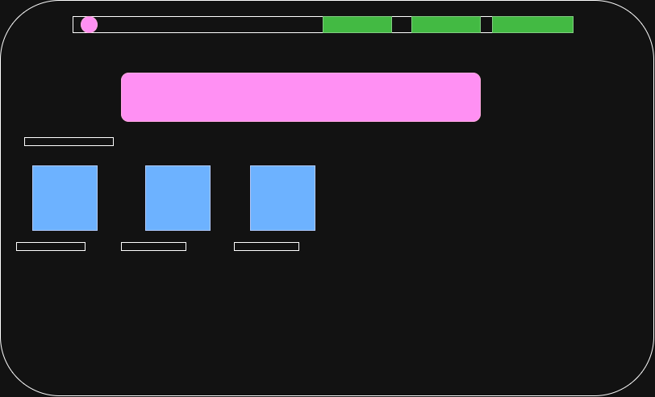
- This is the homepage of my website

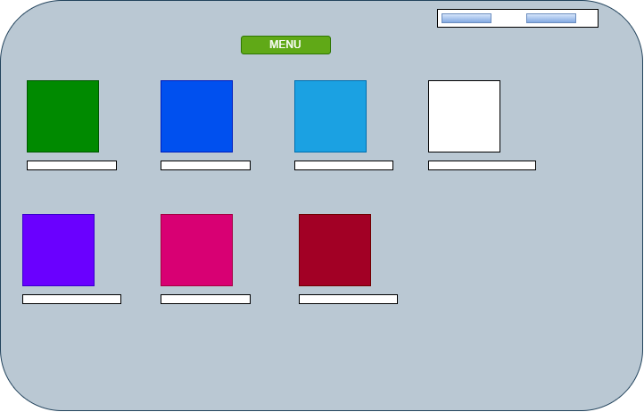
- Menu page

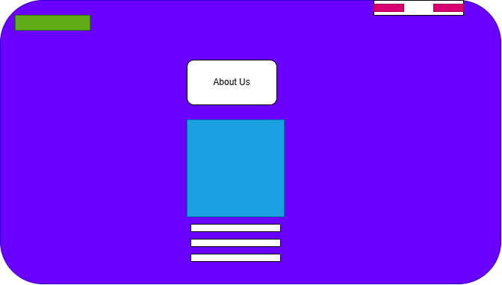

- About Us page

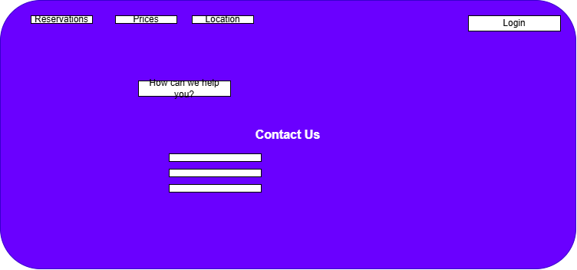

- Contact us Page

